NIT2112 Object Oriented Programming
Flight Information System Assignment
Final Online Submission Due Date: Session 11

Weightage: The assignment is 40% of final mark for the unit.
For this assignment, individual work is required. The assignment consists of three parts, each with its own set of requirements and objectives. Submission details can be found at the conclusion of this document.
Objective:
The task is to create a Flight class that will store various flight details, sort and display them on the console, and eventually on a GUI. This assignment aims to reinforce understanding of class structures, arrays, sorting algorithms, and Java GUI concepts.
Scope:
This project is designed for students enrolled in an introductory Java programming unit. It requires basic proficiency in Java programming and familiarity with object-oriented principles.
Assignment Parts:
The assignment is divided into three parts:
Part 1: Create the Flight class incorporating 10 attributes, such as flight number and departure time. Utilize the Scanner class to gather input values from the user, thereafter, forming an array comprising Flight objects.
Part 2: Integrate the sorting algorithms with a console-based interface to display sorted flight details.
Part 3: Extend the project to include a graphical user interface (GUI) using Java GUI concepts such as Swing to visualize and interact with the flight data.
Resources: Students are encouraged to refer to the lecturer's slides, recommended textbooks, and online resources for learning about class structures, arrays, sorting algorithms, and Java GUI development.

Code SS:
Form1.java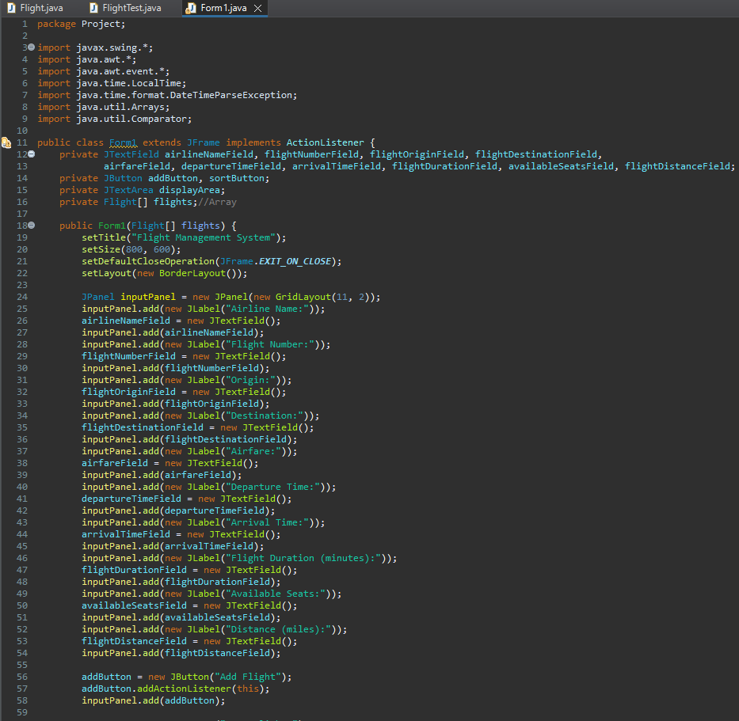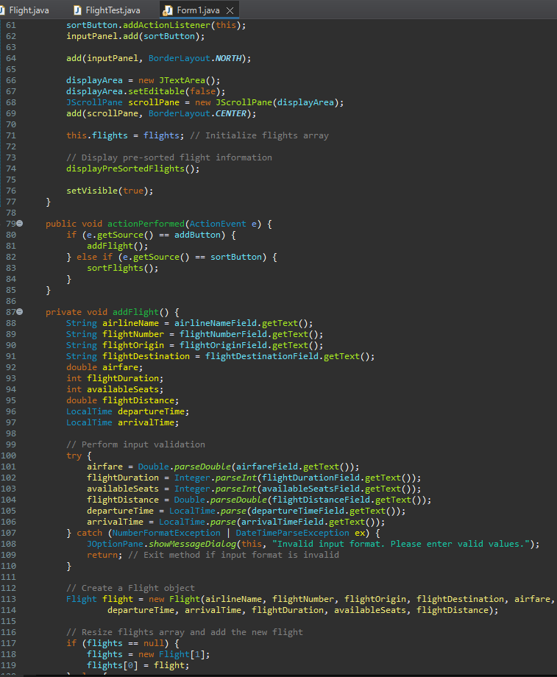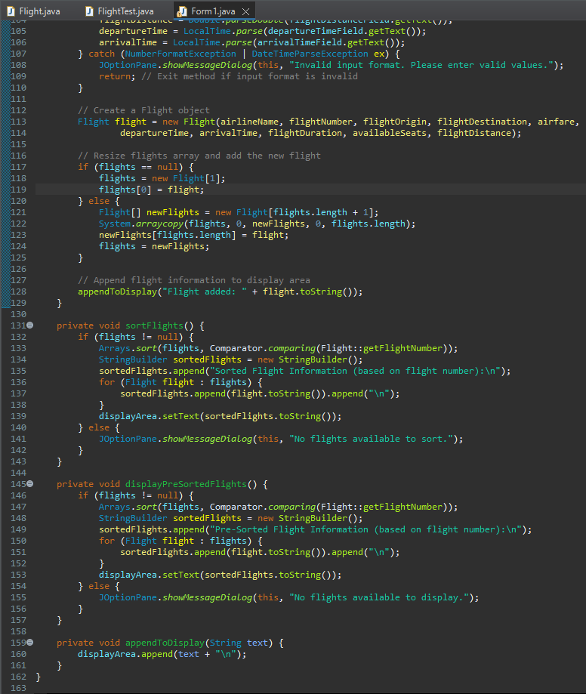

Flight.java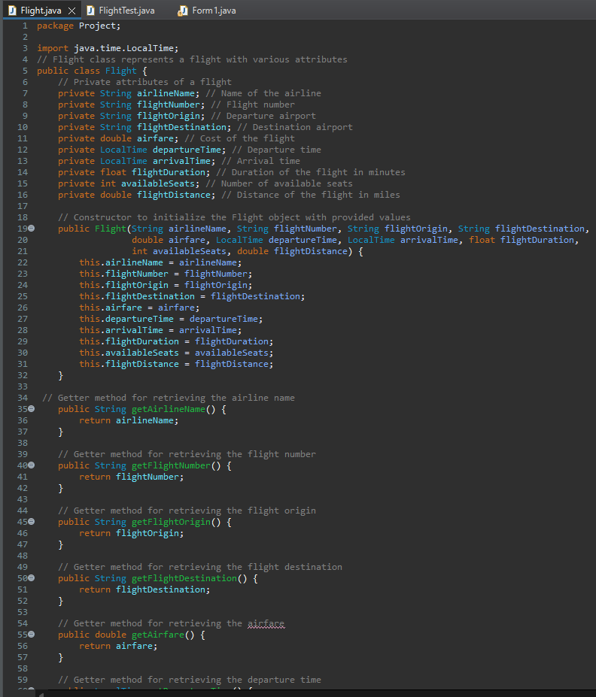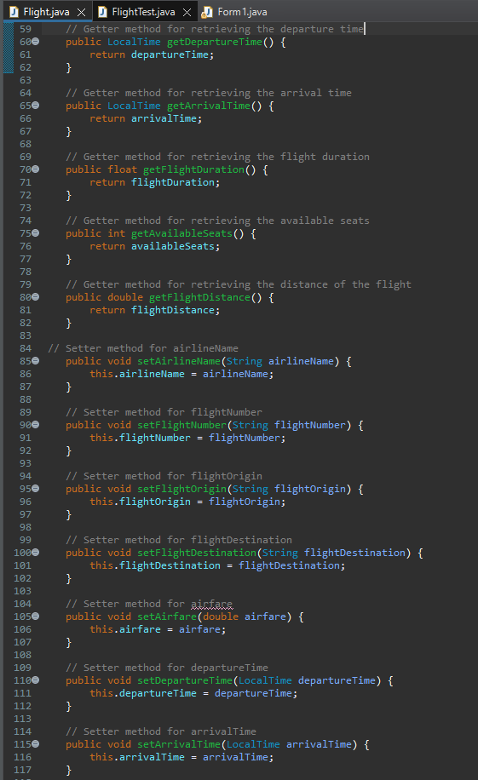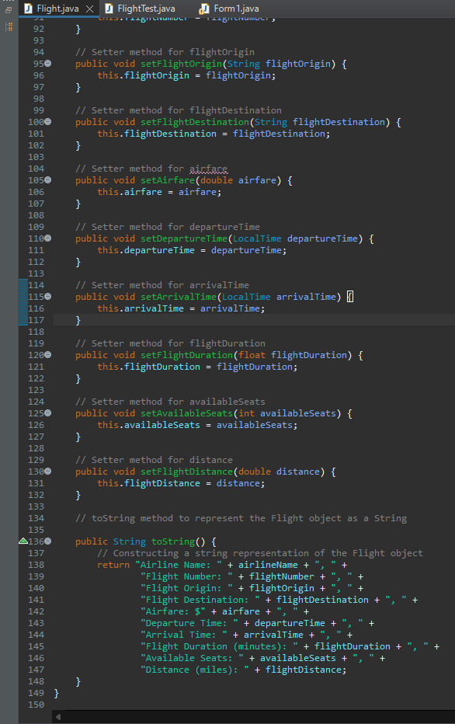
FlightTest.java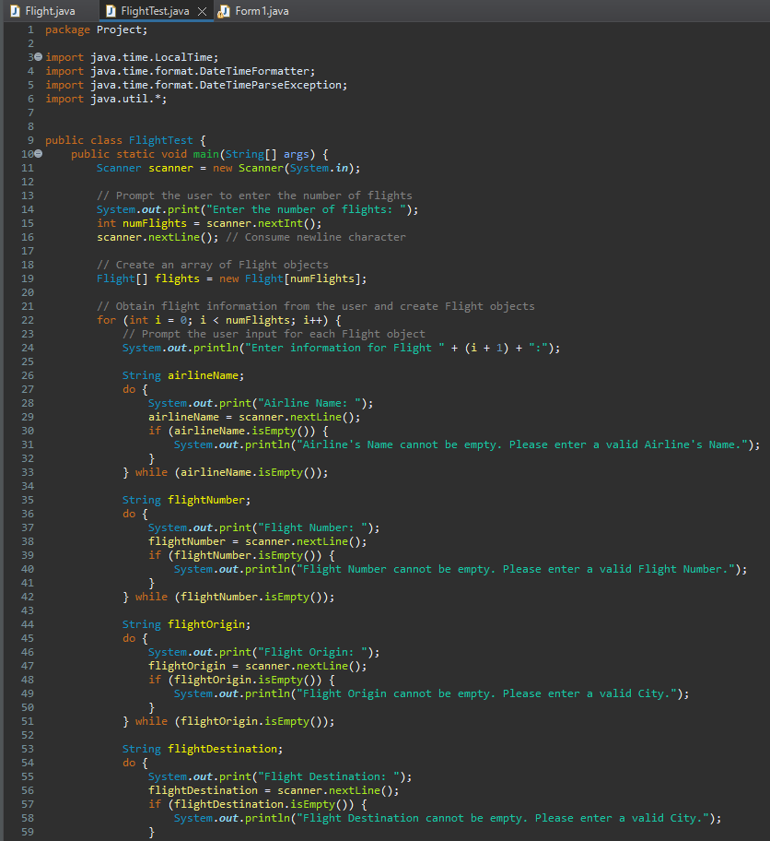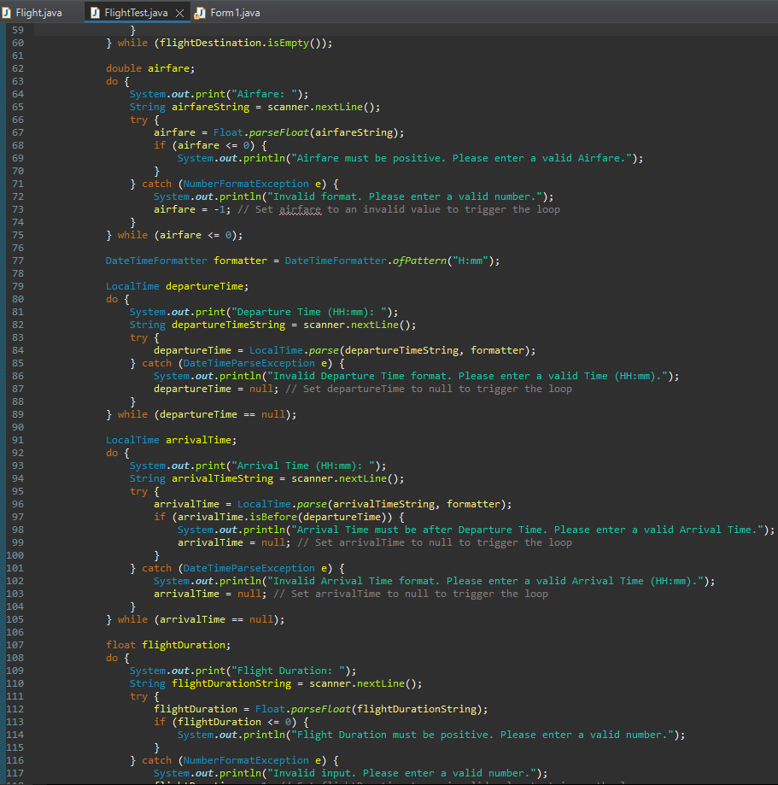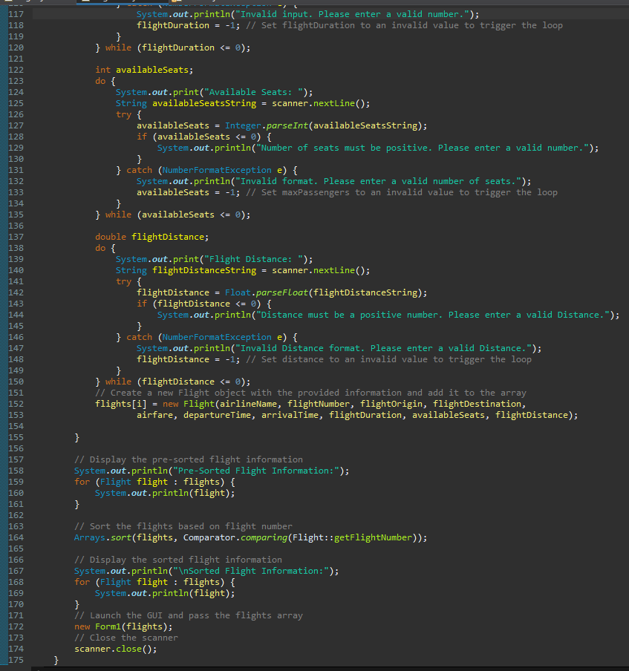

Part 1 - Implementing a Flight Class and Creating Flight Objects with User Input using Scanner Class
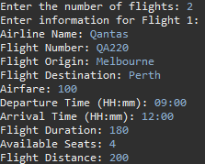
When the code it executed it prompt the user to enter the number of flights they want to input and according to that the for loop is executed.
Part 2 - Sorting Flights Based on Flight Number Attribute
The above image shows the flight detail before and after being sorted when the prompted number of flight details are filled. The details are sorted based on flight number using toString() method.
Part 3 - Implementing GUI for Flight Sorting and Display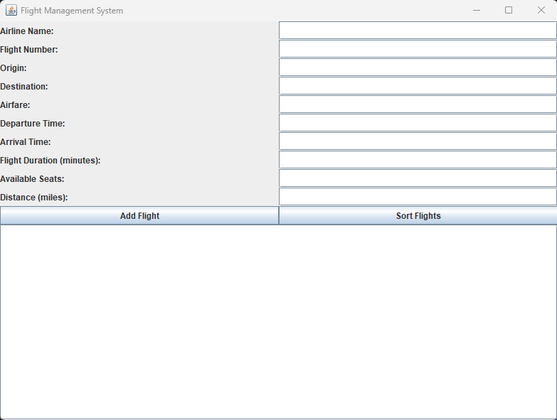

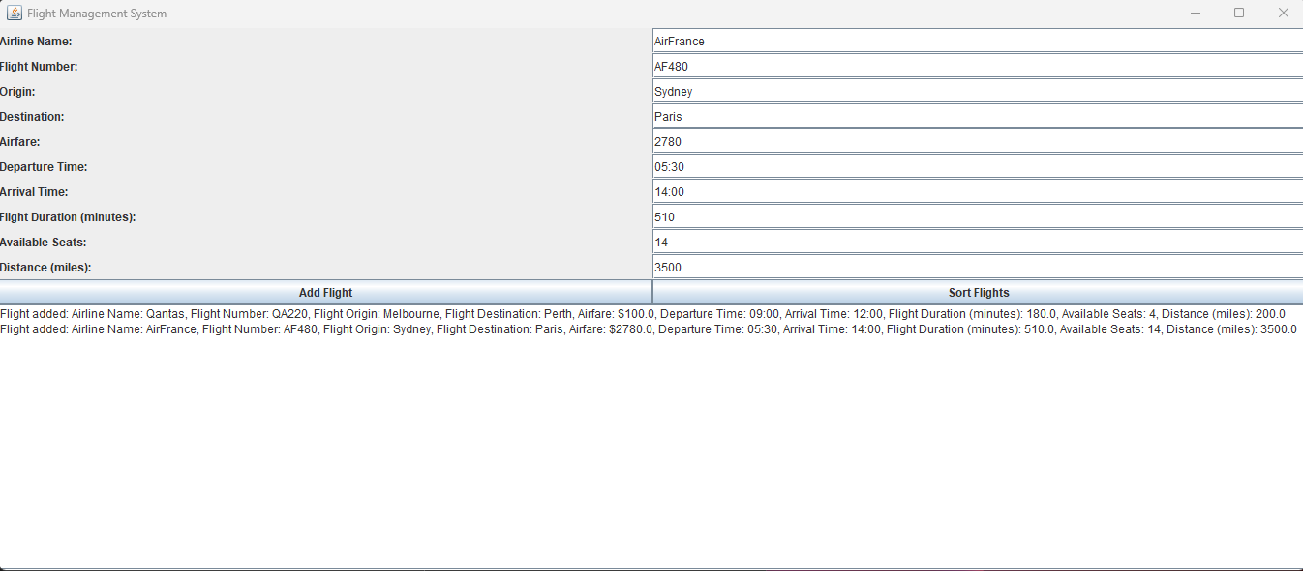
Before Sorting

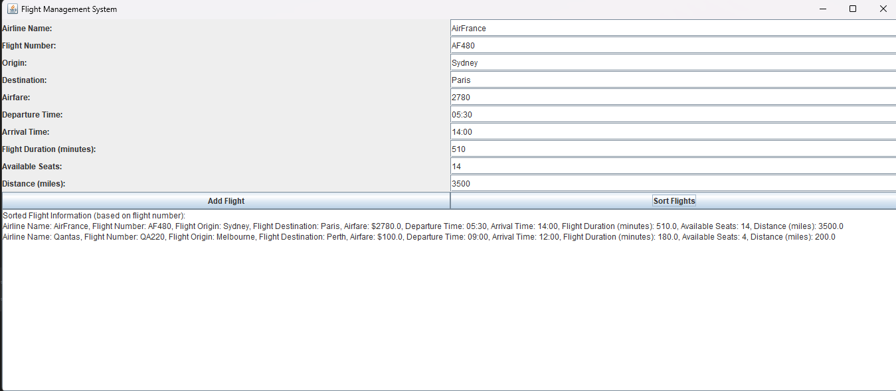
After Sorting

UML Diagram
